CST 370 – Spring A 2020

Homework 3

Name: Randy Son___________________________

Class ID: 7774____________________

How to turn in?

Write your answer to the questions 1 to 5, and submit it on the iLearn. You can submit the file in PDF format. Don’t forget to write your name and class ID number at the beginning of the file.

For Questions 6 and 7, you should submit your C++ source files on the iLearn.

Thus, you have to submit three files (one PDF file and two C++ source file) on the iLearn.
- Note that the due date is 11:55(PM). This is the iLearn’s timestamp, not your submission time. Since there could be a long delay between your computer and iLearn, you should submit early.

- (5 points) Consider the following recursive algorithm.
Algorithm Q(n)
// Input: A positive integer n
if n = 1 return 1
else return Q(n - 1) + 2 * n - 1

(a) Present the return value for Q(1).

(b) Present the return value for Q(2).

(c) Present the return value for Q(3).

(d) Determine what the algorithm computes for a general number n: Q(n).

- (10 points) In the class, you learned the recurrence relation and backward substitution to get the time complexity of a recursive algorithm. To remind the topic, read the Google document again at https://goo.gl/HmoUNQ

Solve the following recurrence relations using the backward substitution. You have to present intermediate steps as described.

(a)
M(n) = 2*M(n – 1) for n > 1 // recurrence relation
M(1) = 3 // initial condition
(b)
M(n) = 3*M(n – 1) for n > 1 // recurrence relation
M(1) = 4 // initial condition

- (15 points) Consider the following recursive algorithm.

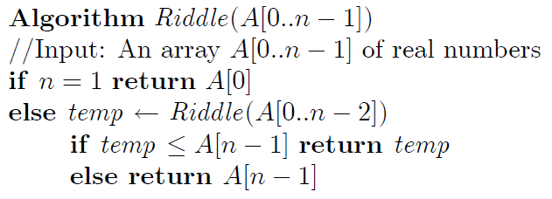

- What does this algorithm compute?

- Set up a recurrence relation for the comparison operation at the “if n = 1” in the line number 3.

- Provide an initial condition for the recurrence relation you develop at the question (b)

- Solve the recurrence relation using backward substitution method. Present the intermediate steps and the time complexity of the result

- (15 points) Consider the following recursive algorithm for positive integer n

ALGORITHM S(n)
//Input: A positive integer n
if n = 1 return 1
else return S(n − 1) + n ∗ n ∗ n

- What does this algorithm compute?
- Set up a recurrence relation for the multiplication as the basic operation
- Provide an initial condition for the recurrence relation
- Solve the recurrence relation using backward substitution method. Present the intermediate steps and the time complexity of the results

- (15 points) Describe an efficient algorithm (in English) for finding all common elements in two sorted lists of numbers. For example, for the lists 2, 5, 5, 5 and 2, 2, 3, 5, 5, 7, the output should be 2, 5, 5. As another example, for the lists 20, 30, 50, 70, 90, 100 and 10, 20, 30, 50, 80, the output should be 20, 30, 50.

[Hint: You can do this task in the linear time.]

- (20 points) Write a C++ program called power.cpp to compute 2^{n} for a nonnegative integer n. In this program, you have to develop a recursive function to calculate it. And also, you can’t use a library in the program.
For the problem, you can assume that the user always enter a correct integer number which is greater than or equal to zero.
[Hint: Use the formula: 2^{n} = 2*2^{n-1} for the recursive function.]

Here are some sample test cases:

Test case 1
Enter a number: 0
Result: 1

Test case 2
Enter a number: 4
Result: 16

Test case 3
- We read your program and check if it uses a recursive function.

- (20 points) Write a C++ program called all_subsets.cpp which displays all subsets of a set. In the problem, your program should read n characters from a user and display all subsets of the characters. In the program, you can assume that the number of input characters is less than or equal to 15. Your program should ask a user to enter the number of input characters. After that, it should read the characters. For the problem, you can assume that the input characters are always distinct.

Test case 1
Number of input characters: 1
Enter 1 characters: a
===== All Subsets =====
empty
{a}

Test case 2
Number of input characters: 2
Enter 2 characters: s t
===== All Subsets =====
empty
{s}
{t}
{s,t}

Test case 3
Number of input characters: 3
Enter 3 characters: c b a
===== All Subsets =====
empty
{a}
{b}
{c}
{a,b}
{b,c}
{a,c}
{a,b,c}

Test case 4
Number of input characters: 4
Enter 4 characters: v x y z
===== All Subsets =====
empty
{v}
{x}
{y}
…
{v,x,y,z}

Test case 5
Number of input characters: 10
Enter 10 characters: a b c d e f g h i j
===== All Subsets =====
empty
{a}
{b}
{c}
…
{a,b,c,d,e,f,g,h,i,j}

